DBSM Report

OOP | 28/11

(Names)

1. Ahmed Nasser Abdelkareem Mohamed (9)
2. Ahmed Khaled abdelsayed abdelaal (5)
3. Mohamed esmail Mohamed Ali (53)
4. Bassam Ashraf elsayed Mattar (16)
5. UML
6. Design Describtion
7. GUI

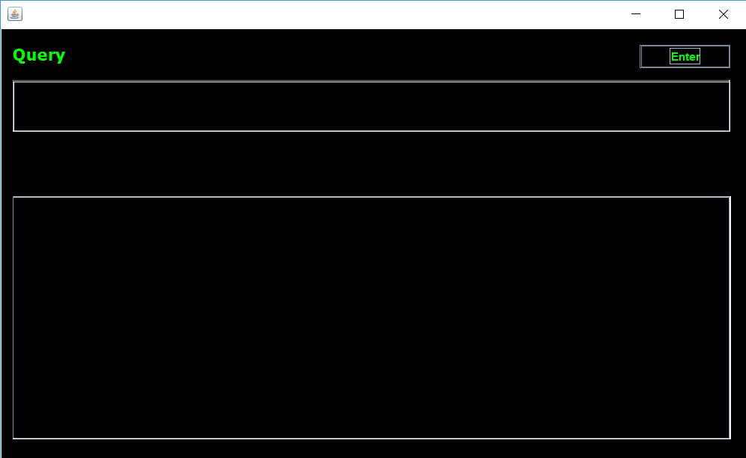

1. User Guide
2. Write your command line in Command Text Field .
3. Press ENTER or Click Execute Button .
4. Get Your Result in The below Text Area .